Fruit Skewers
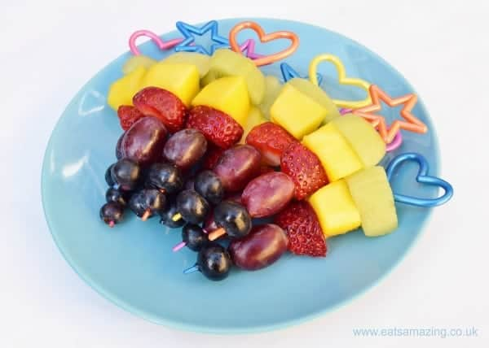
Ingredients;
- 1 kiwi fruit (peeled and chopped)
- ½ mango (peeled and chopped)
- strawberries
- red grapes
- blueberries
- skewers
- yoghurt (optional)
Method;
- Wash the strawberries, grapes and blueberries in cold water and pat dry with kitchen towel.
- Cut the tops off the strawberries and discard.
- If the strawberries are big, cut them in half or into large chunks. Cut the grapes in half if wanted.
- Put all of the fruit into bowls.
- Slide the fruit on to the skewers.
- Dip in yoghurt (optional)

