Cotton Bud Painting
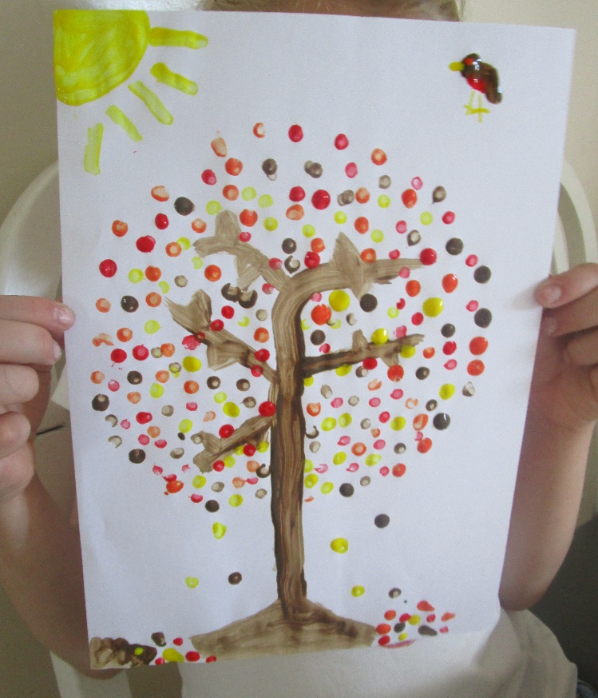

You will need;
*paper
*cotton buds (or the blunt end of a pencil)
*paint

Method;
- Dip the cotton bud in the paint and dab on to the paper
- Leave to dry

