Sock Puppets
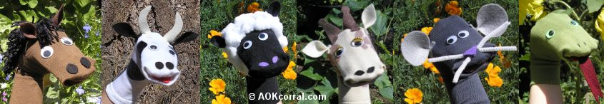
You will need;
*socks
*felt
*wool
*cotton wool
*googly eyes
*scissors
*glue
*needle and thread
*pen

Method;
1) put the sock on your hand and mark out where the ears, eyes, tongue and nostrils will go
2) cut out ears from felt and glue them onto the sock
3) glue the eyes and nostrils on
4) glue the wooly hair on
5) cut a pink tongue from the felt and glue that in place
6) if you are happy with the position of everything then stitch them in place so they are secure

