Milkshakes
Strawberry and banana
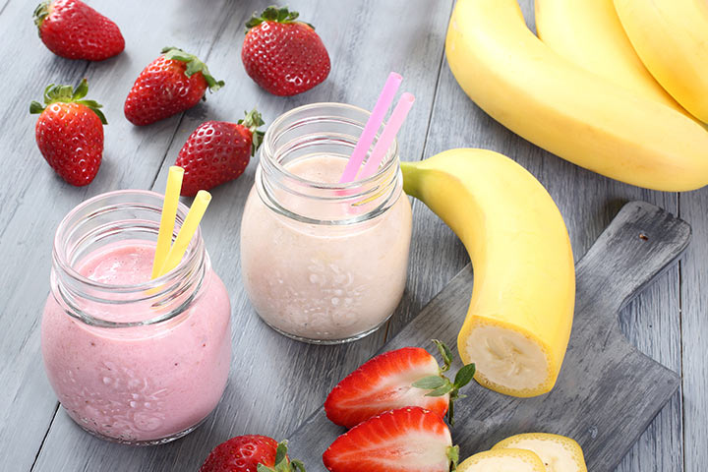
Ingredients;
- 2 cups of cold milk
- 1 cup of strawberries, chopped
- 4 Tbsp of sugar
- 4 ice cubes
- 2 bananas, chopped

Method;
- Add the milk, bananas, strawberries, ice cubes, and sugar into a blender jar. Churn well until smooth.
- Pour into a glass and serve immediately.

Lemon
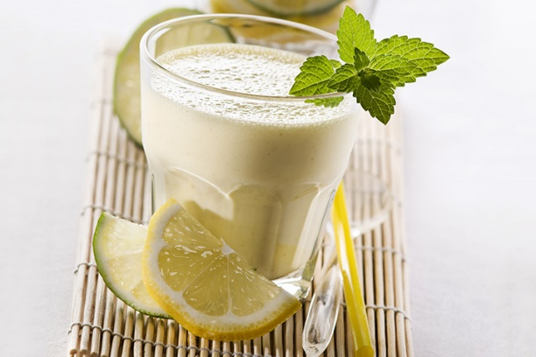
Ingredients;
- 1 cup of milk
- 2 Tbsp of sugar
- 1 medium sized banana
- 3 Tbsp of lemon concentrate
- ½ cup of vanilla ice cream
- 1 cup of ice cubes

Method;
- Put all the ingredients into a blender jar. Churn until smooth.
- Serve chilled.

Apple and cinnamon
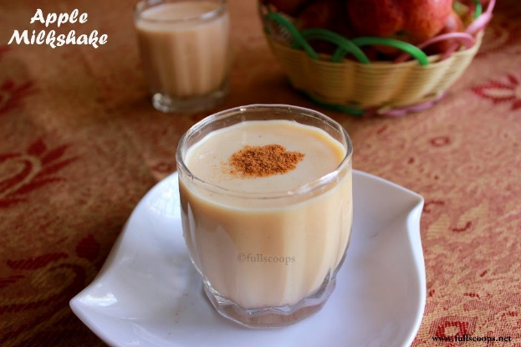

Ingredients;
- Apple - 1.5 cups, peeled & chopped
- Milk - 2 cups
- Sugar - 2 tbsp
- Cinnamon powder - 1/2 tsp

Method;
- Put all the ingredients into a blender jar. Churn until smooth.
- Pour into glasses and sprinkle a little cinnamon on top.
- Serve immediately.

