Leaf Painting
You will need;
*leaves
*paper
*paint
*brushes
*water

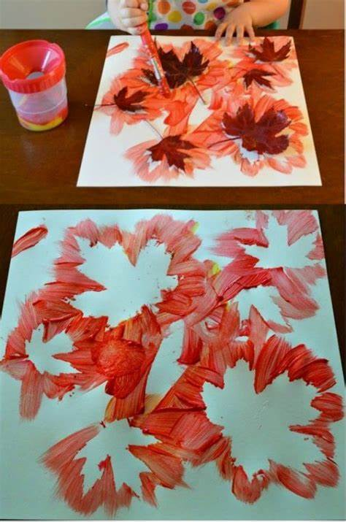
Method 1;
- Press the leaves on the paper.
- Paint around the edges.
- Lift leaves off.
- Set aside to dry.

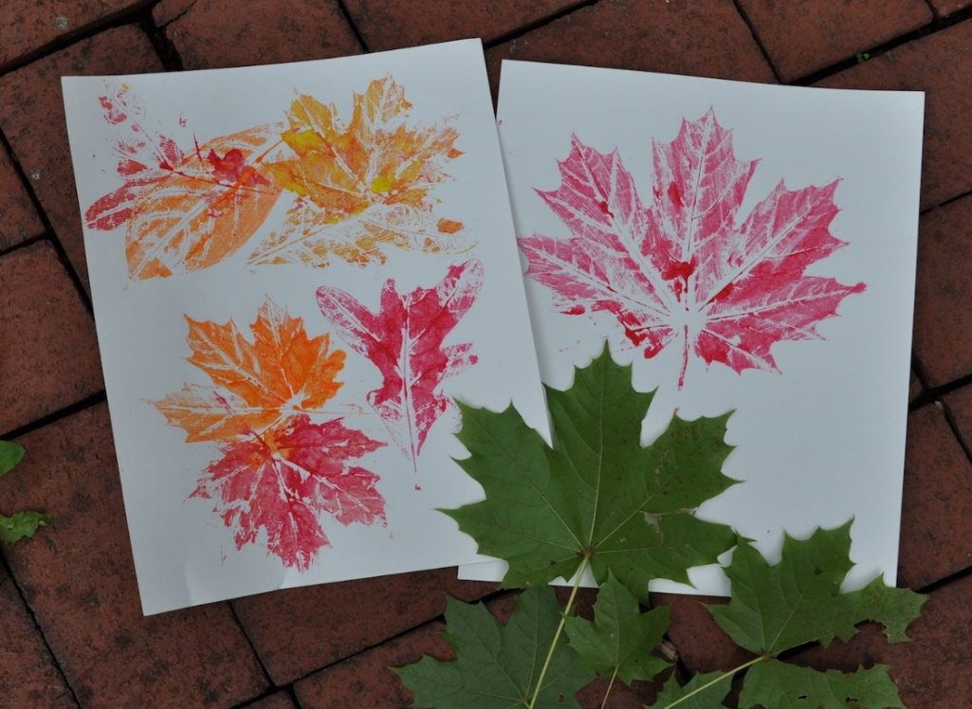
Method 2;
- Paint the leaves.
- Press onto paper.
- Peel back.
- Set aside to dry.

