October 2016 | KidZone Playscheme Activity Plan
 | Monday 24th | Tuesday 25th | Wednesday 26th | Thursday 27th | Friday 28th
Craft 1 | 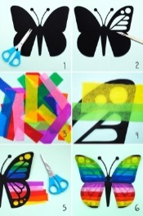  Butterfly/Beatle Silhouette Picture | 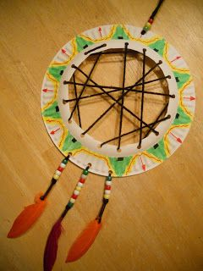  Paper Plate Dream Catcher | 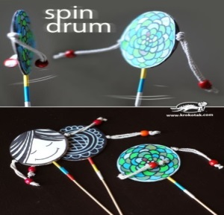  Spin Drums | 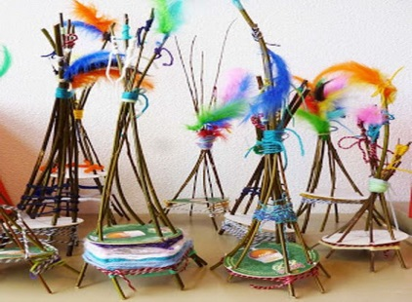  Twig Tipi | 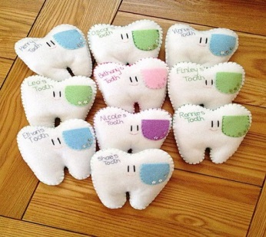  Felt Tooth Fairy Pillows
Craft 2 | 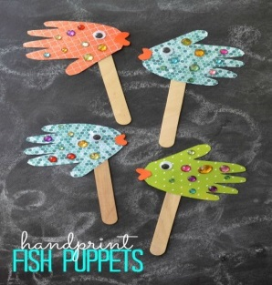  Hand Print Fish | 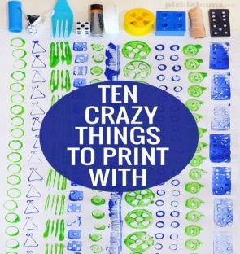  Pattern Printing | 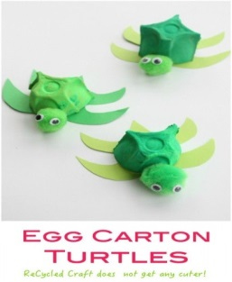  Egg Carton Turtles | 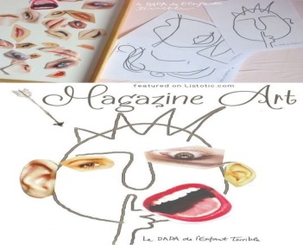  Mr Potato Head Magazine Collage | 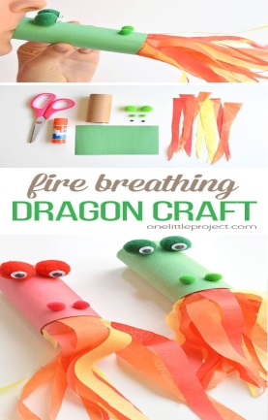  Fire Breathing Dragons
Cooking | 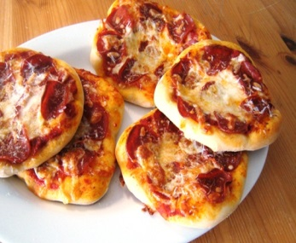  Pizza | 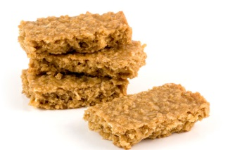  Flapjacks | 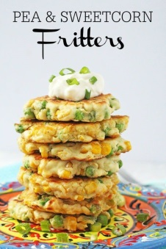  Pea & sweetcorn fritters | 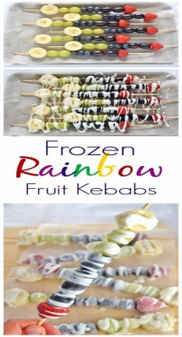  Frozen Fruit Skewers | 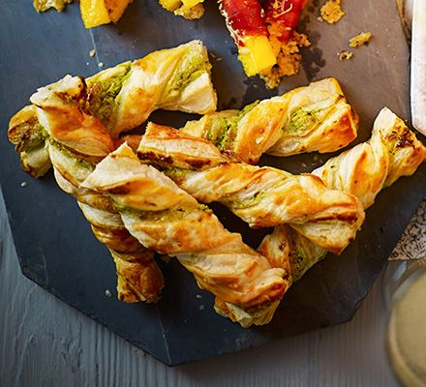  Cheesy pesto twists

