Flapjack
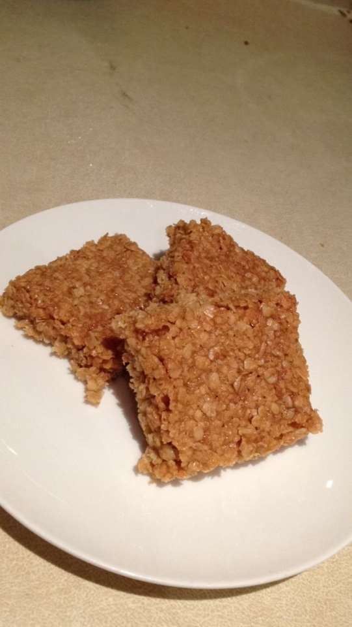
Serves: 6
Ingredients;
250g porridge oats
120g caster sugar
125g butter
3 tablespoons golden syrup

Method;
- Preheat the oven to 200 C / 180 C fan / Gas 6.
- Line a 28x16cm (3cm deep) baking tray with greaseproof paper.
- Mix the oats and sugar into a large mixing bowl.
- In a small saucepan over a medium heat, melt the butter and golden syrup.
- Once the butter has melted, add it to the bowl with the oats and sugar then mix well making sure there are no dry patches.
- Scoop the mixture in the prepared baking tray and press down with the back of a spoon to compact (and squashing it into all the corners).
- Bake in the oven for 15 to 20 minutes until golden brown.
- Once it has cooked take it out the oven and the baking tray and cut into 6x6cm squares.
- Then let them cool for 10 minutes.

