Lolly Stick Bookmarks
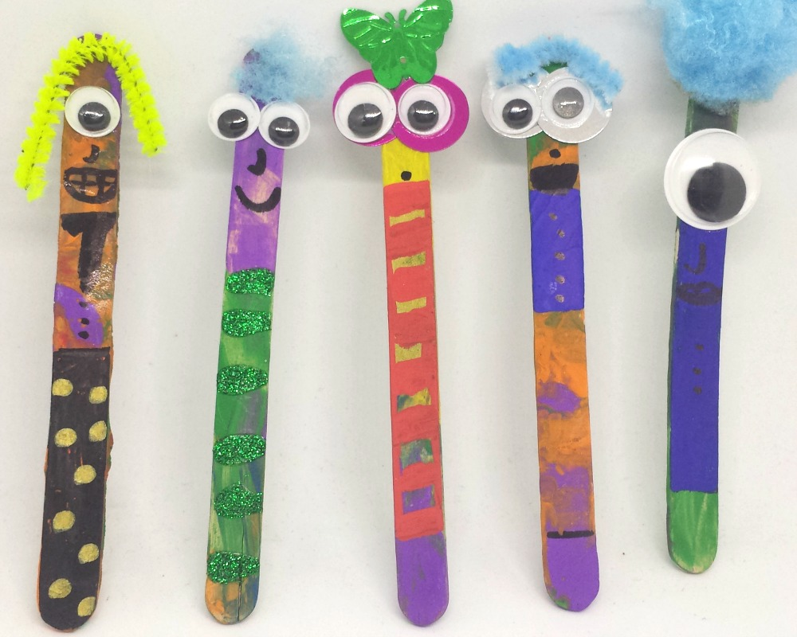
You will need;
*lolly sticks
*paint
*pom poms
*pipe cleaners
*googly eyes
*glue
*scissors
*pens

Method;
1) Paint the lolly sticks
2) Glue the eyes on
3) Draw a nose and mouth
4) Glue on some hair

