Egg Box Penguins
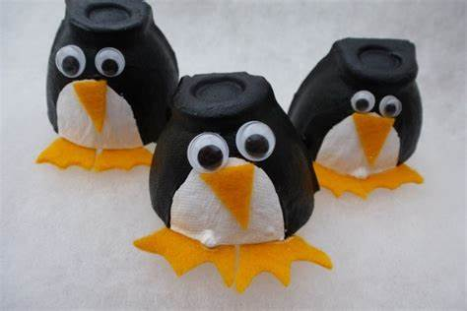
You will need;
*Egg box
*Scissors
*Yellow or orange card or felt
*Googly eyes
*Glue
*Black and white paint
*Brushes

Method;
- Cut off a segment of egg box
- Paint a white circle as the belly
- Paint the rest back
- Cut out a beak and two feet from the card or felt
- Glue them on along with the eyes
- Leave to dry

