Pebble Painting
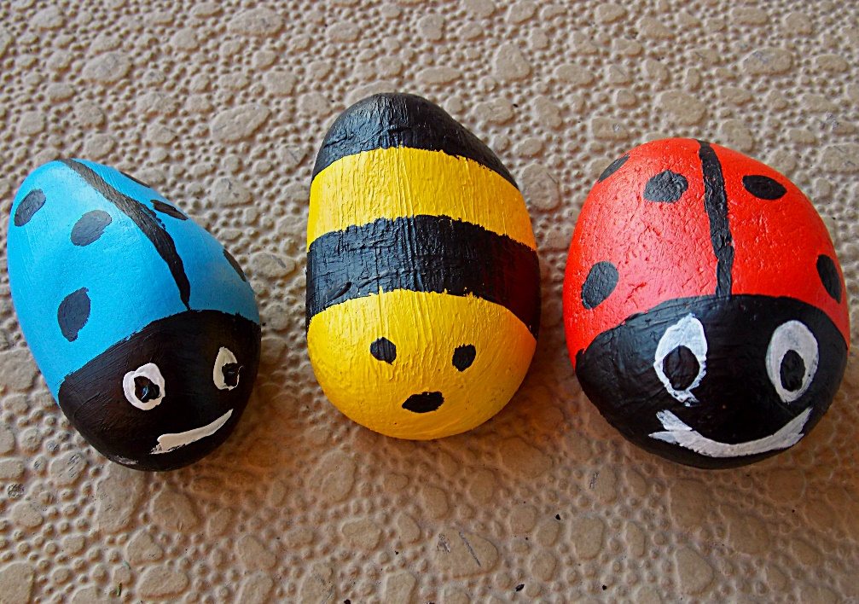

You will need;
*pebbles
*paint (use acrylic if you want to put them outside- but wear an apron as acrylic paint will stain!)
*brushes

Method;
- Find a good sized pebble
- Wash the pebble and pat dry
- Paint on your design (you may want to leave it to dry between layers)
- Once dry you can hide them around the house or in the garden for someone to find

