Cherry and Almond Muffins
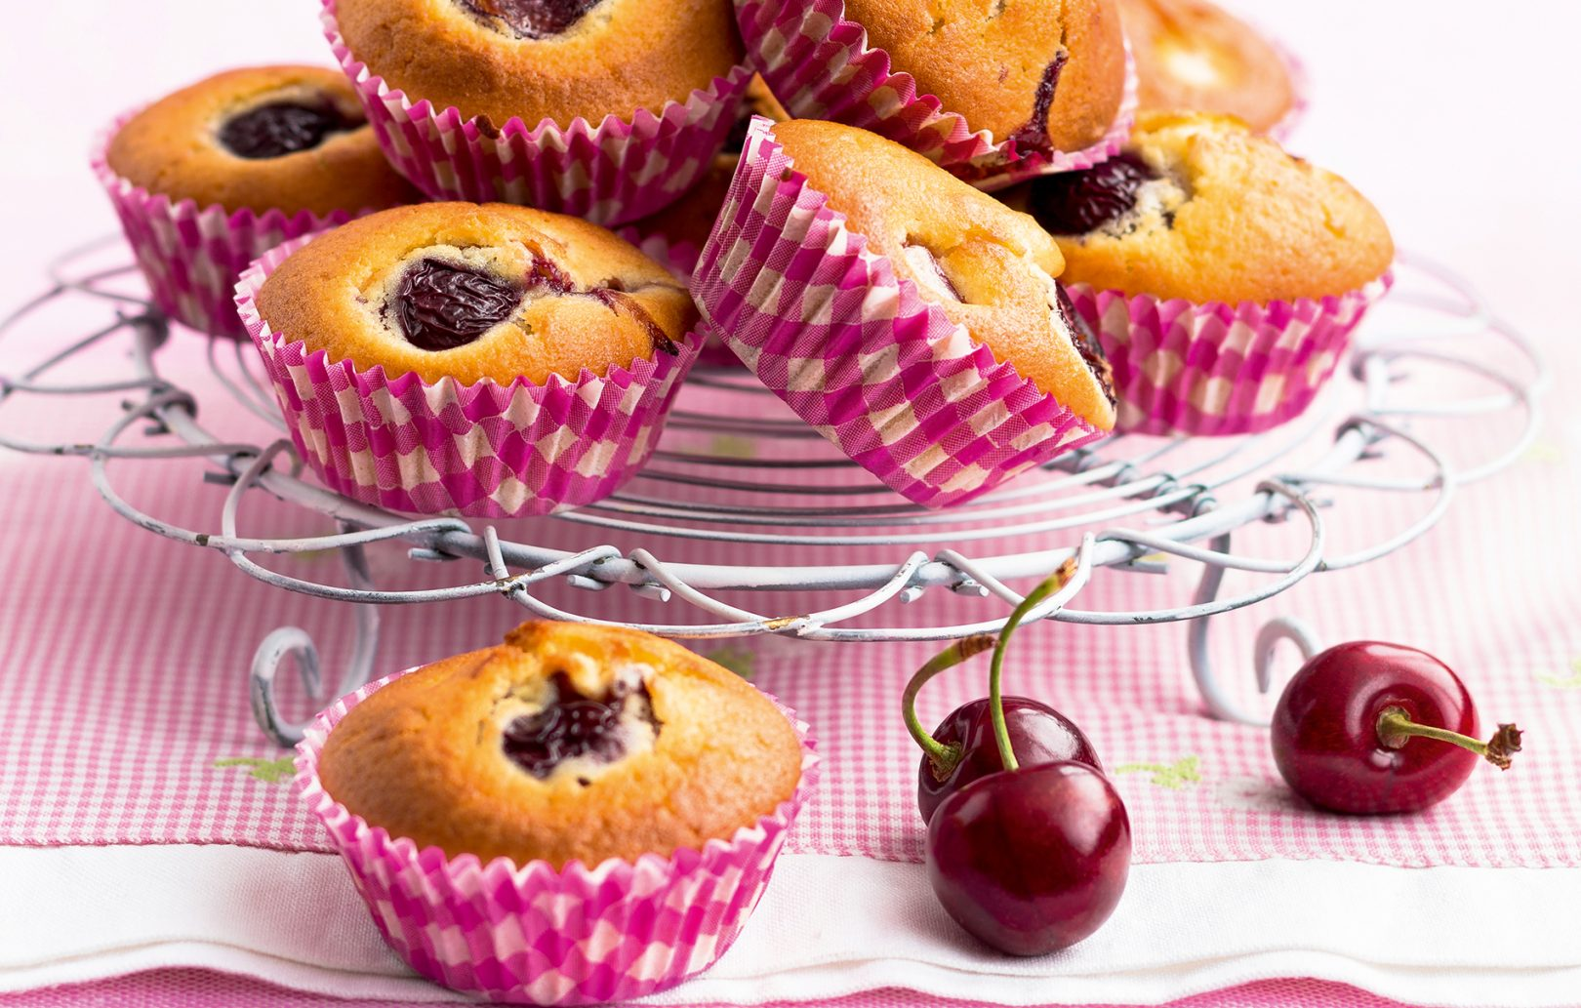
(Makes 12)

Ingredients;
175 grams Melted Margarine
175 grams Golden Caster Sugar
300 grams Self-Raising Flour (sieved)
3 Medium Eggs
5 tablespoons Milk
1 teaspoon Almond Essence
½ teaspoon Baking Powder
250 grams Glace cherries

Method;
- Preheat the oven to 180°C/350°F/Gas Mark 4.
- Place 12 muffin cases into a muffin tray.
- Add all the ingredients except the cherries into a bowl, and beat with a wooden spoon until the mixture is smooth.
- Reserve some cherries for decoration and fold the remainder into the mixture.
- Divide mixture evenly between the paper cases, and decorate the tops with remaining cherries.
- Bake for 20-25 minutes, then leave to cool.

