Paper Plate Jellyfish
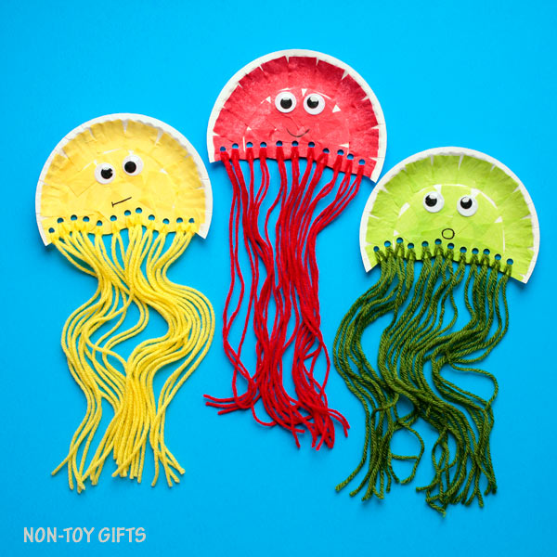
You will need:
*paper plate
*hole punch
*wool
*googly eyes
*glue
*scissors
*pens
*tissue paper

1) Cut plate in half
2) Hole punch the flat edge
3) Cut lengths of wool
4) Lace wool through the holes and tie off
5) Rip small pieces of tissue paper
6) Glue tissue paper onto paper plate
7) Glue googly eyes onto the plate
8) Draw a mouth

