Lemon Cupcakes
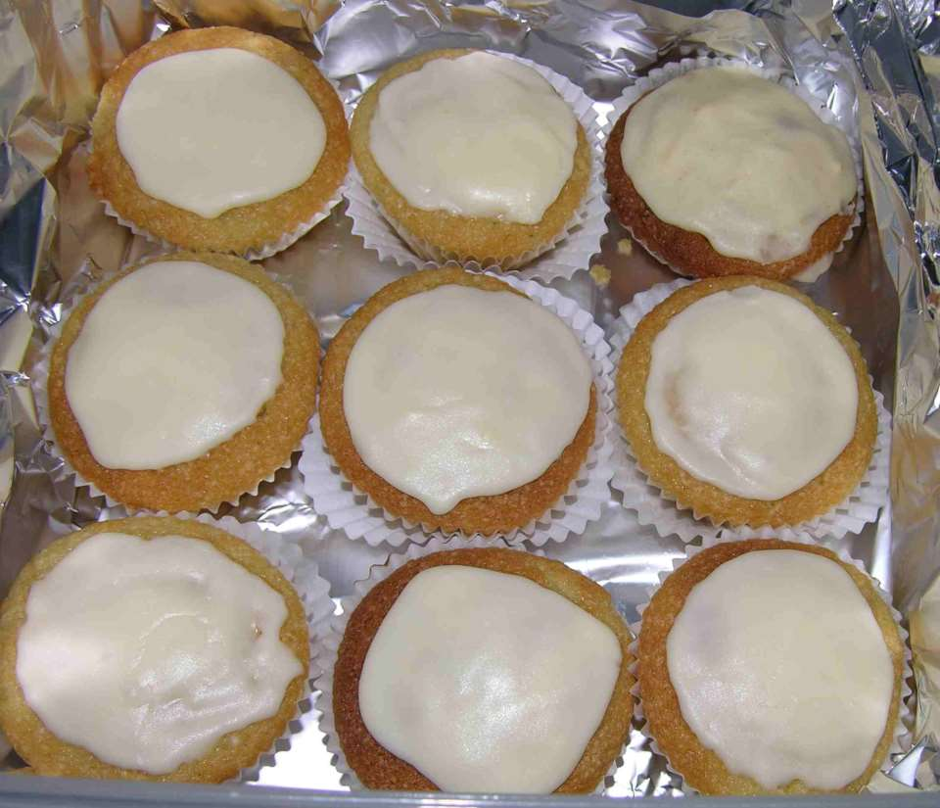
Makes: 12 cakes

Ingredients;
Sponge=
113g (4oz) caster sugar
113g (4oz) butter
60ml milk
1 egg
113g (4oz) self-raising flour
2 drops lemon flavouring
Icing=
140g (6oz) icing sugar
1 drop lemon flavouring
1 tablespoon of water, or more as needed

Method;
- Preheat the oven to 180 C / Gas 4.
- Put the 113g sugar and 113g butter in a bowl and cream together well.
- Put 60ml milk into a measuring jug and then add 1 egg and give a quick whisk with a fork.
- Add the flour and 2 drops lemon flavouring to the butter and sugar mix then pour in the milk and egg and mix together well.
- Bake in oven until a sharp knife inserted in the middle of a cupcake comes out clean, about 12 minutes.
- Leave to cool completely.
- Put the icing sugar in a bowl, add 1 drop lemon flavouring and 1 tablespoon of water and mix together well. If the icing is too thick, add a very small amount of water.

