X’s photo here

X’s Task Checklist

Lesson:

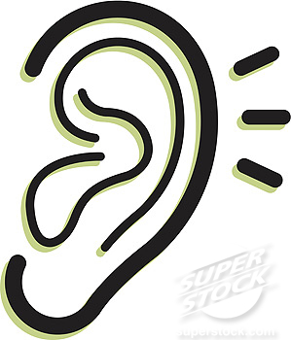 Listen to the Teacher or Teaching Assistant.
 Look at the Teacher or Teaching Assistant.

What do I need for this lesson?
What do I need to do first?
What do I need to do next?
What do I need to do then?
What do I do when I have finished?

