Pizza Faces
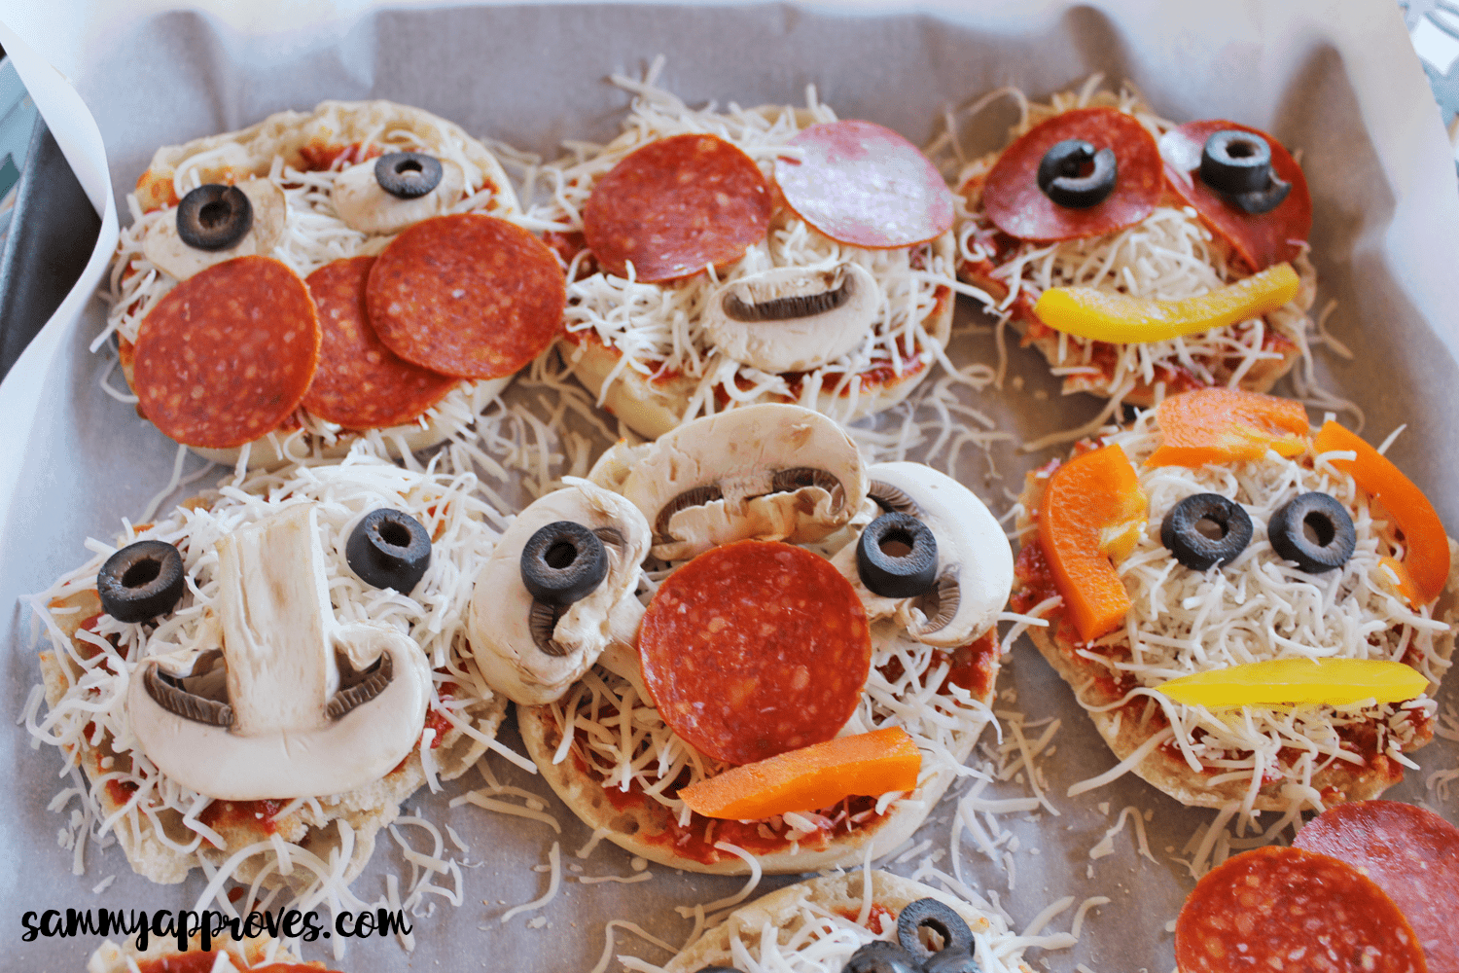

Ingredients;
- Grated cheese
- Sliced vegetables- such as mushrooms, tomatoes, olives, sweetcorn, broccoli, carrot, red onions, and peppers
- Sliced pepperoni, ham, or pieces of cooked chicken
- Pineapple (Optional)
- Tomato Paste
- English Muffins
Method;
- Cut the muffins in half.
- Spread tomato paste over one side.
- Put your ingredients into bowls on the table.
- Have your kids arrange different faces on the muffins. Get creative with moustaches, eyes, noses, ears, smiles, eyebrows, hair and teeth.
- Bake your pizzas at 350 for 10-12 minutes or until the cheese has melted.
- Let the pizzas cool for a few minutes before serving.

