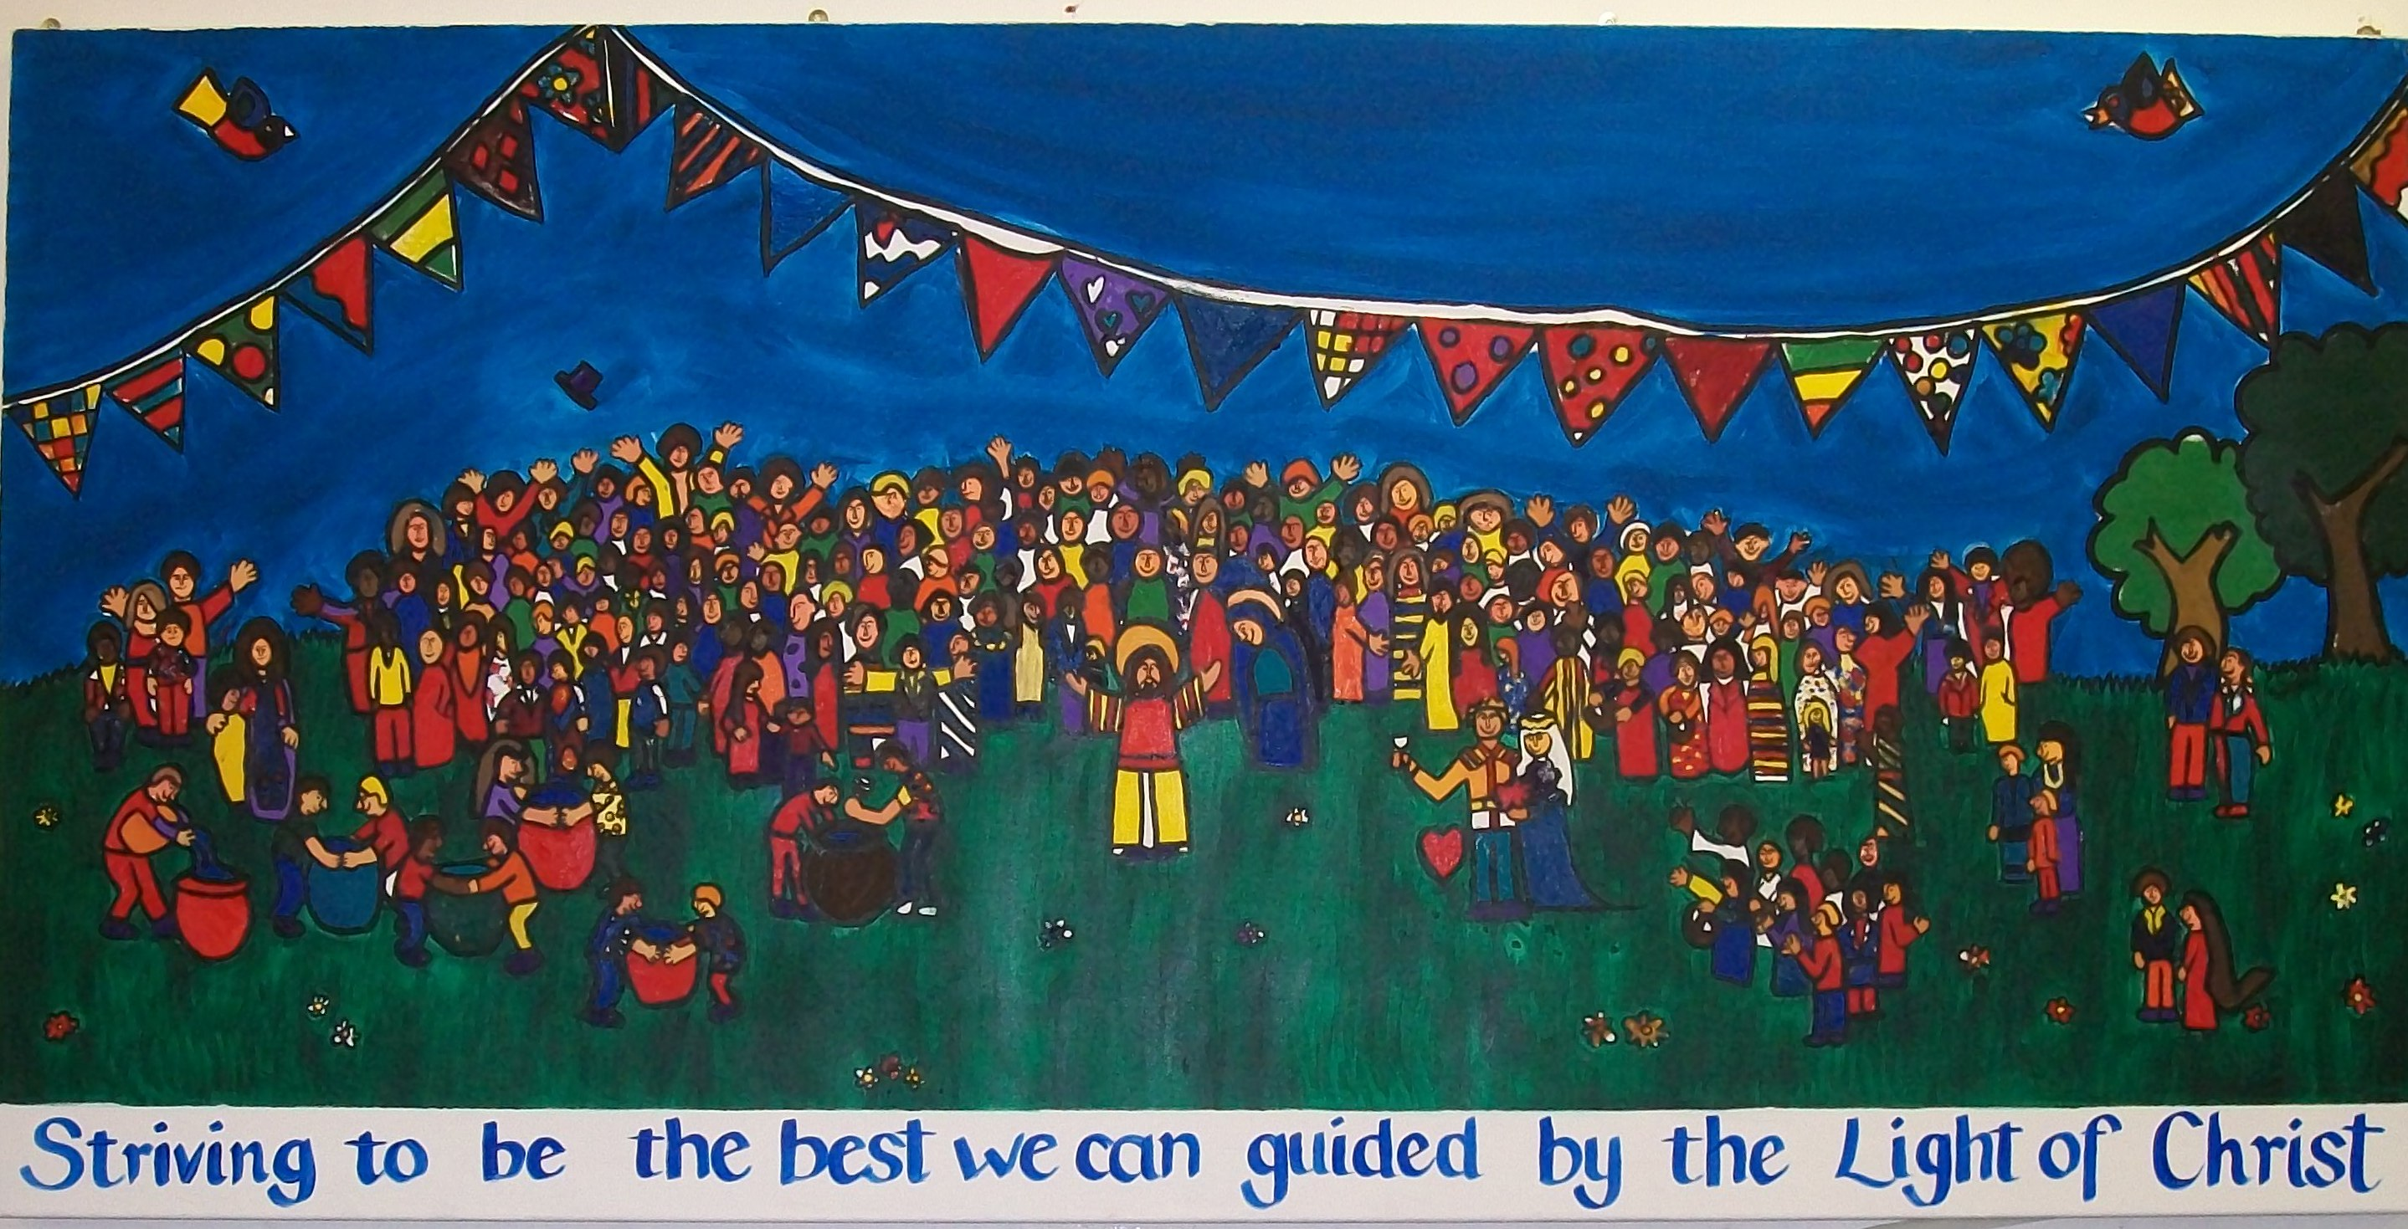

SAY “NO” TO BULLYING BEHAVIOUR
If someone is unkind to you  1. Tell an adult straight away.  2. Don’t be afraid of telling someone.  3. Make sure you tell them everything that has happened, so that they can help you.  4. If it happens again you must tell an adult.  We want you to feel happy and safe!  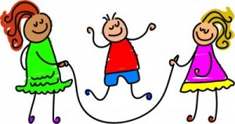 |  | If you are unkind to someone  1. You will be asked to explain what you’ve done to an adult. This will be written down.  2. You will have to talk to Mrs Charles about what you’ve done.  3. Your parents might have to come into school to talk about your behaviour.  4. If you’ve chosen to treat someone unkindly you will have to miss a playtime or spend time out of your class.  5. You will be expected to apologise to the person you have upset.

Remember always treat others as you want to be treated.

