Pancakes

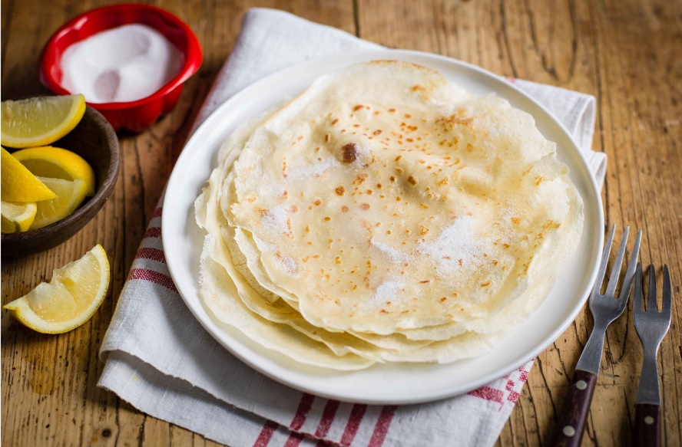

Ingredients;
- 150g plain flour
- 300ml semi skimmed milk
- 2 medium eggs
- 1½ tbsp olive oil

Method;
- Sift the flour into a large bowl and make a well in the centre.
- Crack the eggs into the well and whisk, drawing in the flour from the sides of the bowl.
- Gradually add the milk and continue whisking, until you have a smooth batter.
- Leave to stand for 30 mins.
- Brush a 20cm frying pan with a little oil and warm on the hob, over medium heat.
- Add a tbsp of the batter to the pan, tipping gently until it coats the base in a thin layer.
- Cook for 1-2 mins, or until golden, then carefully flip the pancake over and cook the underside for 1 min more.

