Cheese Straws
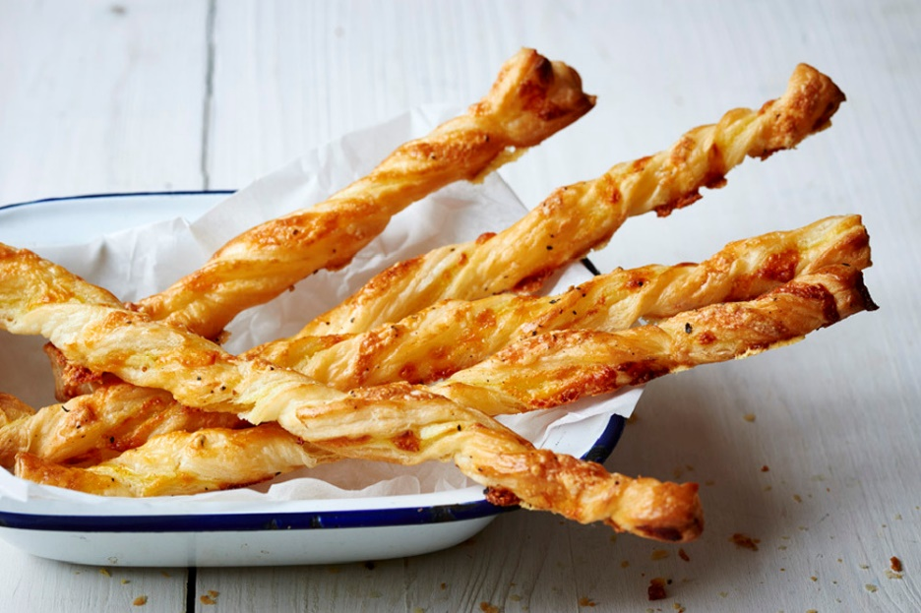
Ingredients:
- 375g ready-made puff pastry
- Plain flour, for dusting
- 1 tbsp English mustard (optional)
- 100g cheddar, grated
- Freshly ground black pepper
- 1 egg, lightly beaten
Method:
- Preheat the oven to 200C/200F/Gas Mark 6.
- Line a baking tray with greaseproof paper.
- Roll the pastry out, on a lightly floured work surface, into a large rectangle around 0.5cm thick.
- Turn the pastry so that the longest side is facing you, spread the mustard evenly on the pastry, sprinkle with the cheddar and season with plenty of black pepper.
- Cut the pastry into long strips.
- Carefully twist each piece of pastry 4 or 5 times so it looks like a curly straw, then place on the baking tray.
- Chill the pastry twists in the fridge for 15-20 minutes.
- Brush the straws with the beaten egg.
- Bake them for 20-25 minutes, or until the pastry is well risen and golden brown.

