Vegetable Printing

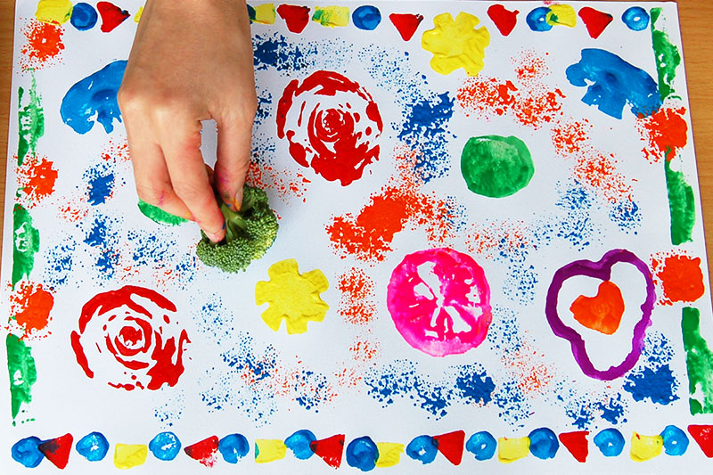
You will need;
*vegetables (such as pepper, carrot, onion, tomato, broccoli, celery, lettuce)
*paper
*paint
*brushes

Method;
- Cut the vegetables in half
- Brush the surface of the veg with paint
- Press the veg on to the paper
- Leave to dry

