String Painting
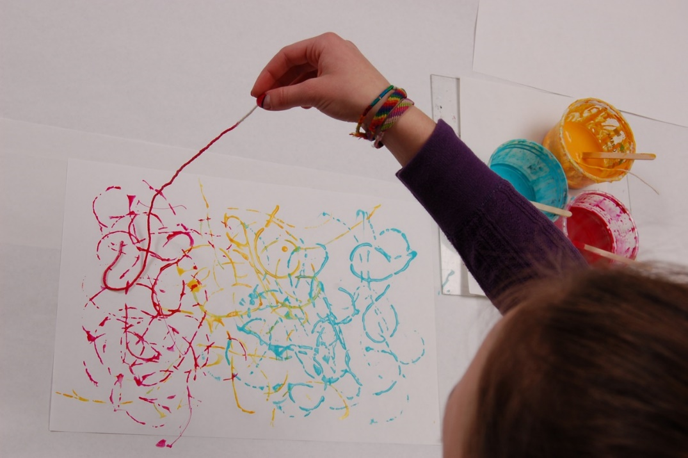
You will need;
*String
*Scissors
*Paint
*Paper

Method;
- Cut lengths of string
- Dip in the paint
- Drop on the paper
- Leave to dry

