Fish Shaped Pizza Pittas
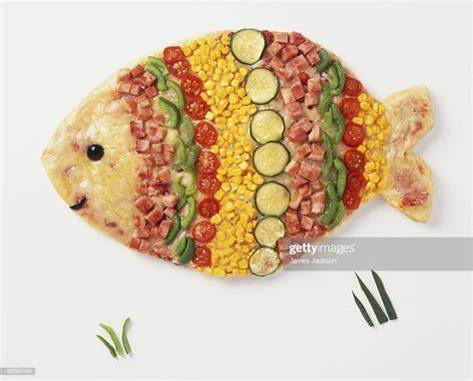

Ingredients:
*4 large pitta breads
*4 tbsp tomato purée
*2 tsp mixed herb
*2 tomatoes, sliced
*6 slices salami, torn into small pieces
*50g cheddar, grated

Method:
- Heat the grill
- Cut a triangle away from one end to make a fish tail
- Spread the pitta bread with 1 tbsp tomato purée, place the triangle in the centre of the pitta as a fin
- Next, sprinkle over the mixed herbs and then lay on the tomato slices
- Divide the salami between the pittas, sprinkle over the cheese
- Grill until the cheese is golden and bubbling

