Dream Catcher
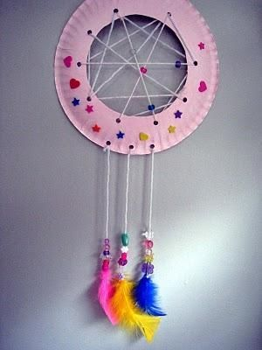
You will need:
*Paper plate
*Scissors
*Hole punch
*Wool
*Beads
*Feathers

Method;
1) Cut the middle from a paper plate
2) Punch holes around the edge of the plate
3) Weave the wool from hole to hole
4) Thread some beads onto some lengths of wool and tie feathers to the end
5) Tie on to the plate
6) Tie a loop to the top of the plate to hang it up

