Apple Crumble
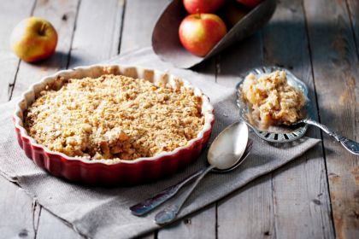
Ingredients;
- 3 large cooking apples
- 3 tbsp caster sugar
- 3 tbsp water
- 125g plain white flour
- 75g butter
- 25g demerara sugar
- 50g porridge oats

Method;
- Peel, core and slice some cooking apples (or whatever fruit you are using) and put them in the bottom of an oven proof dish
- Sprinkle with caster sugar and water
- Mix the flour, marg and brown sugar until they are like breadcrumbs or, alternatively whizz the mixture for 15 seconds in a food processor
- Stir in the oats and put the mixture on top of the apples
- Bake at 190'C/Gas mark 5 for 40 to 45 mins
- Allow to cool slightly and serve custard, cream or vanilla ice-cream

