Cheese & Onion Pasties
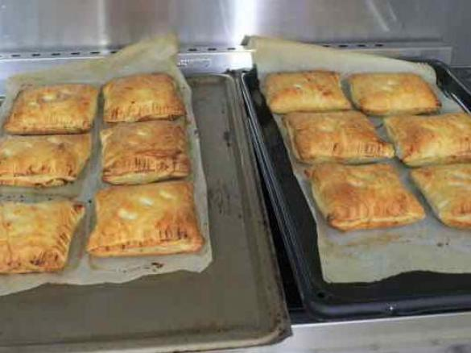
(12 pieces)
Ingredients;
6 sheets ready Rolled puff pastry, cut each square into 2 to give 12 pieces
2 onions, quartered
500 grams potatoes, peeled and cubed into 3cm
125 grams Milk
250 grams Cheddar Cheese, cut into cubes
20 grams Butter
salt and pepper to taste
1 egg, beaten for brushing pastry
Method;
- Grate cheese and set aside.
- Peel and chop potatoes very small and set aside.
- Chop onions finely and add to pan.
- Add butter, cook onions in a pan for 5 mins on low heat until soft.
- Add potatoes, salt and milk, cook 25 mins.
- When potatoes are soft, add butter.
- Season with salt and pepper.
- Pre heat oven to 200c while filling is cooling.
- When cooled, spoon filling onto one half of the pastry, brush pastry edges with beaten egg, fold over to form a square sealing edges with a fork.
- Cut steam slashes onto top of pastry. Brush over with beaten egg.
- Place on a baking tray lined with baking paper. Bake in oven for 20 minutes until golden.

